**CLASS 21**

**ANSIBLE**

-> it a free and opensource tool.

-> it is an IT engine which automates from sever creation to deployment.

-> It is also called as conguration management tool.

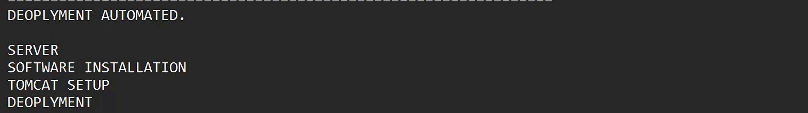



Ansible work with yaml language.

Ansible dependency is python.

GUI for ansible is Ansible -Tower

Playbook: code to perform any task – if you want to work with any kind of work you have to write a code

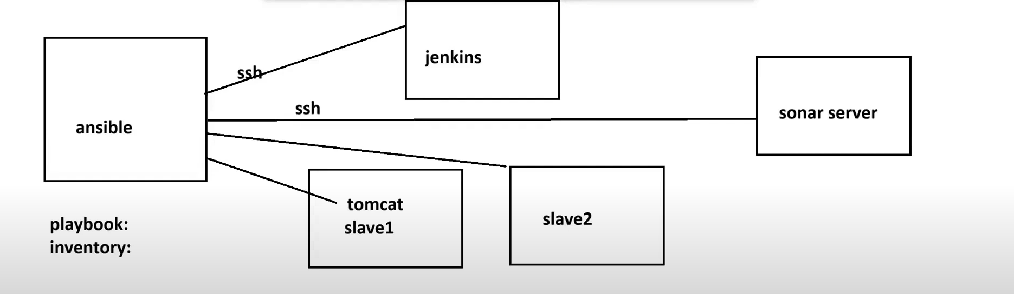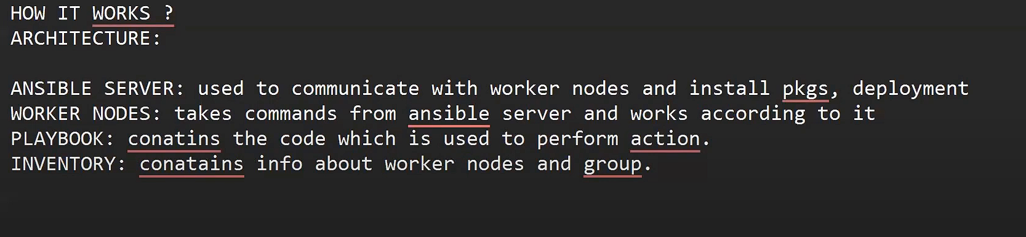

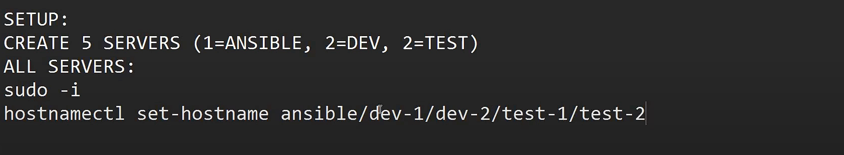

Here you kneed to set the hostname for each server seperately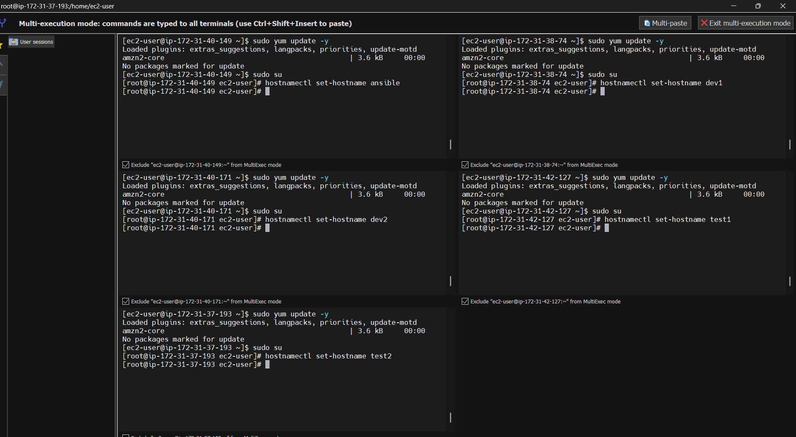

Now again login using sudo -i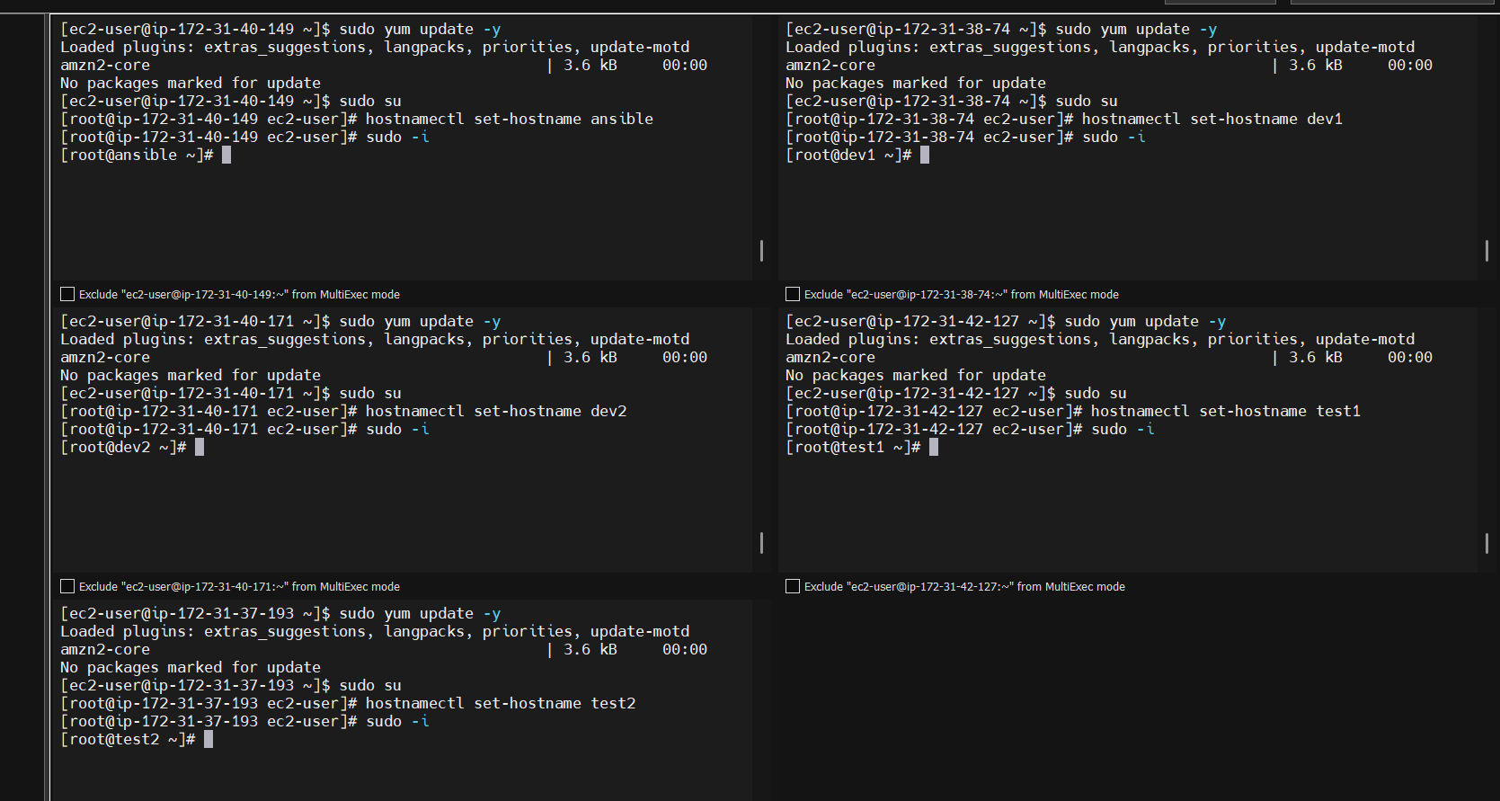write passwd root to set a password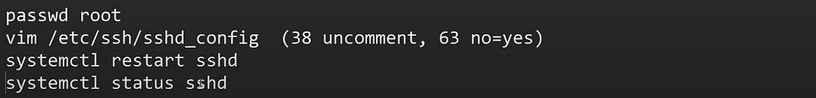sudo vim /etc/ansible/hosts

Line 12 write like this and give ip of worker nodes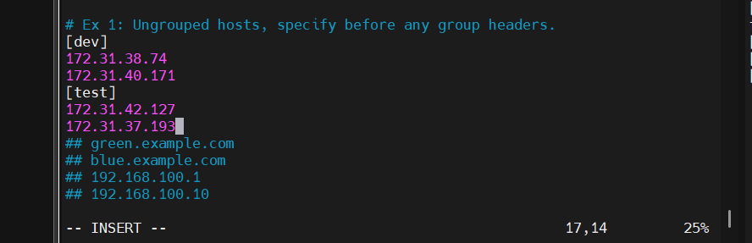

Ssh-keygen //ued to generate the keys

Enter 4 times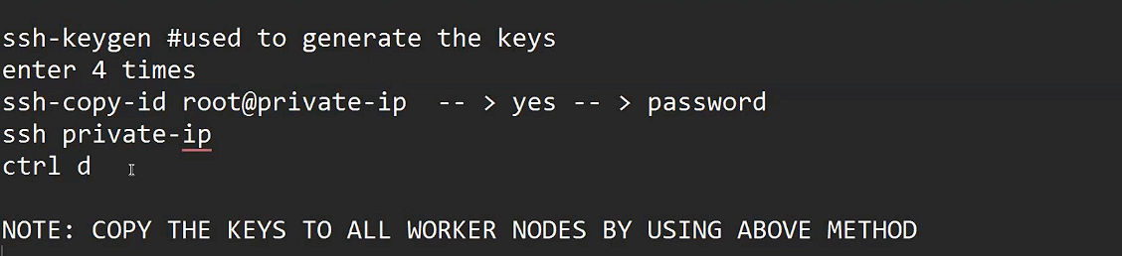

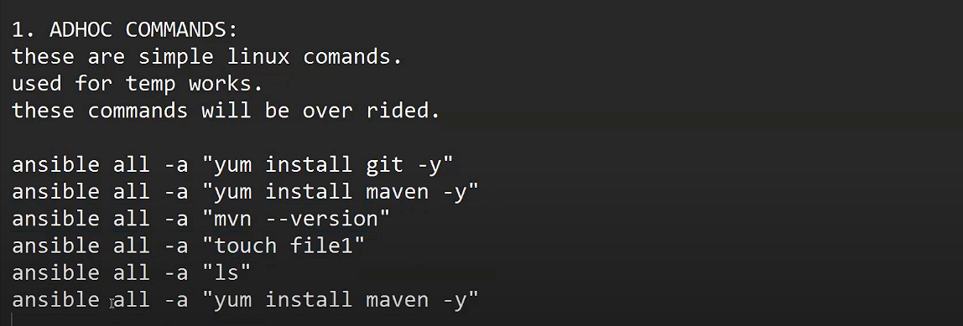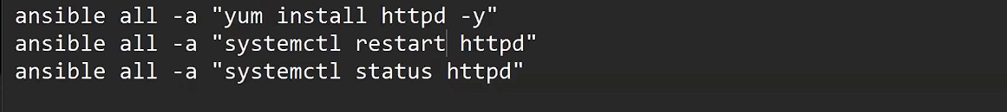-here with a single command in anisble user we can install git in all worker nodes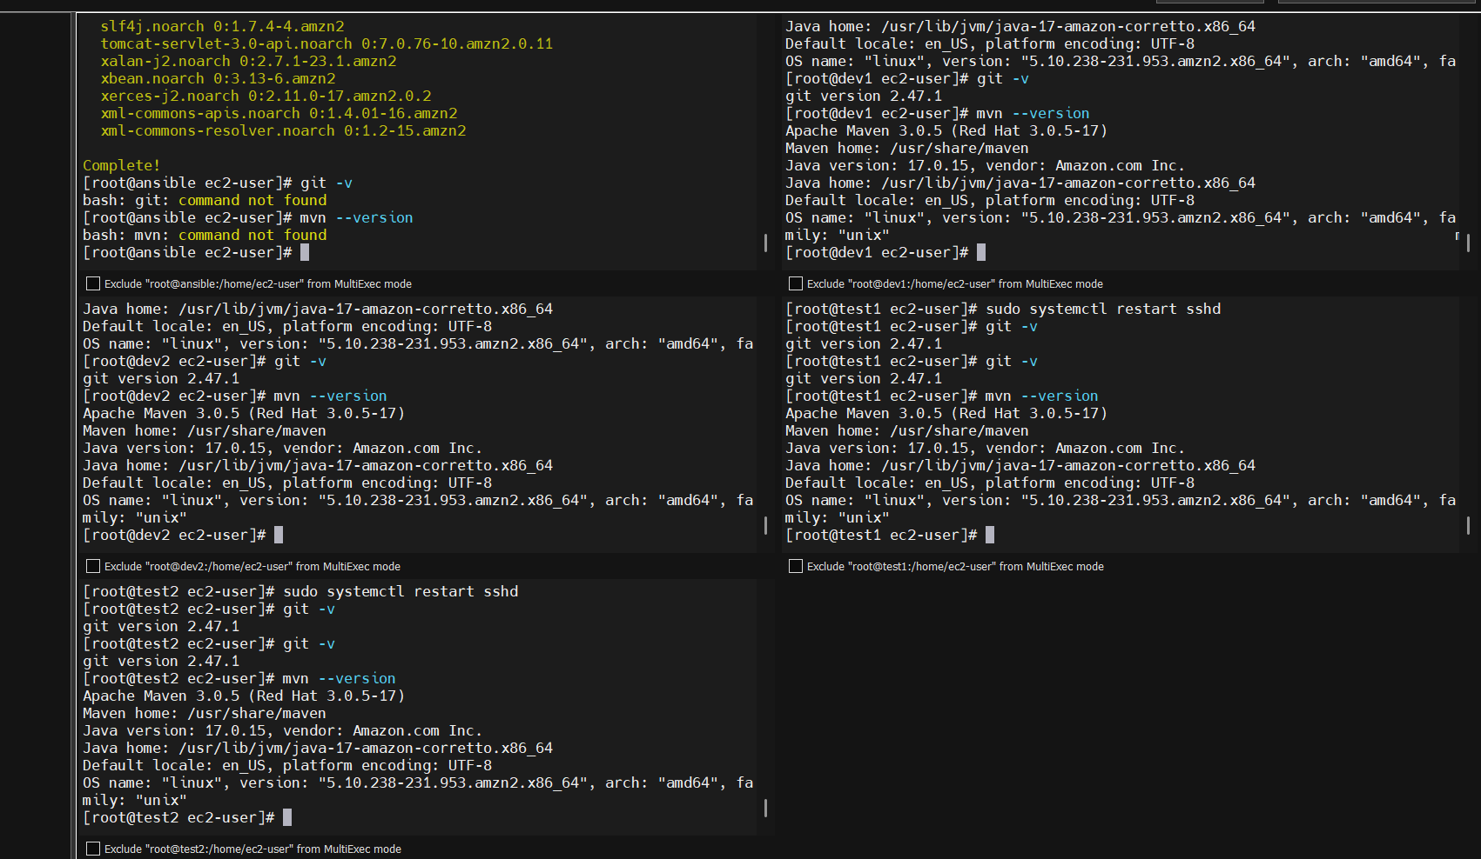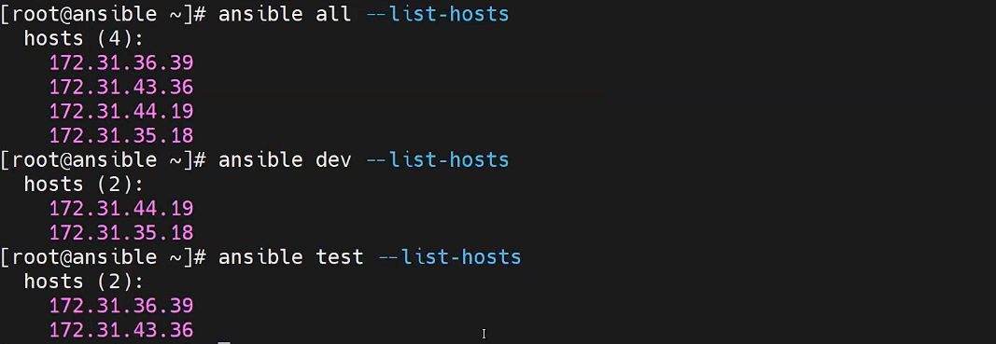

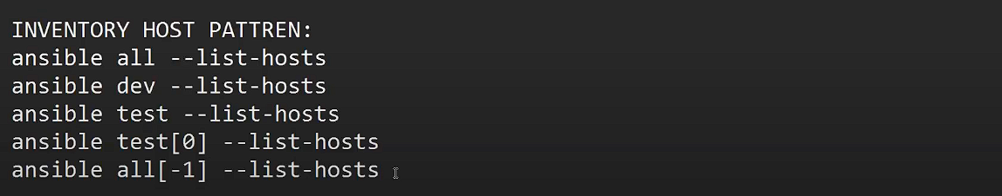

**CLASS 22**

**ANSIBLE MODULES**

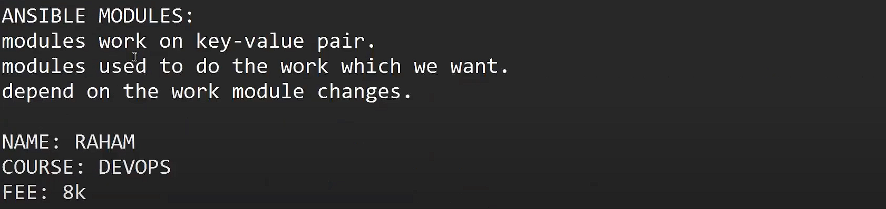

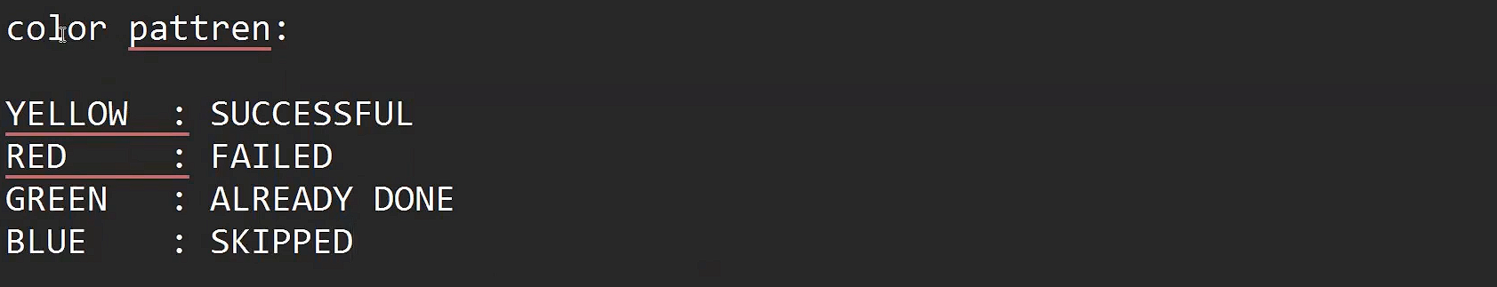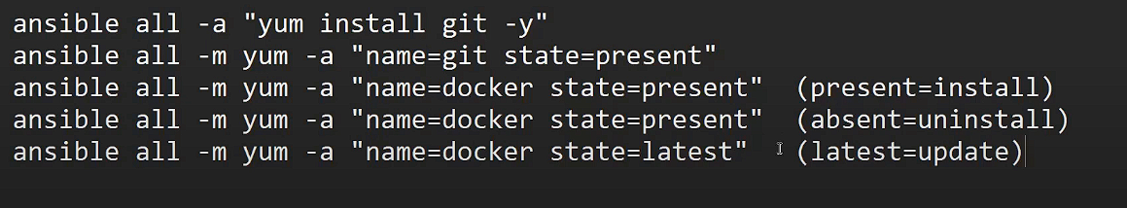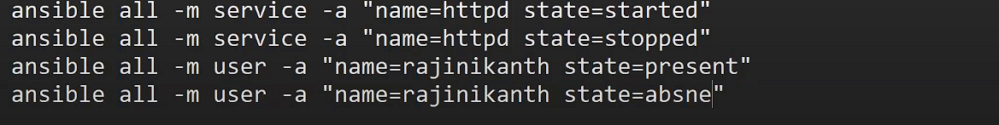

App.yaml – it is a text file which contains the properties of application (important file)

PLAYBOOK :

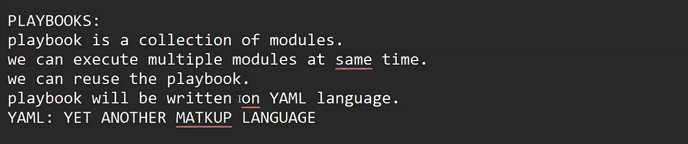

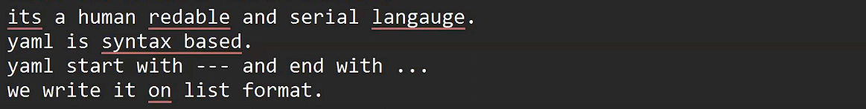

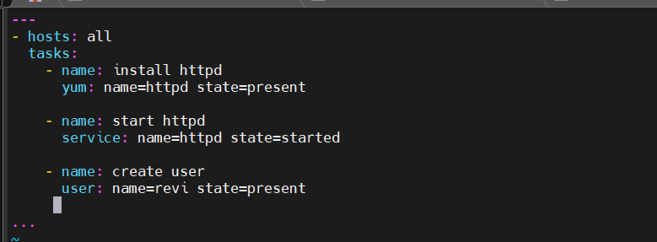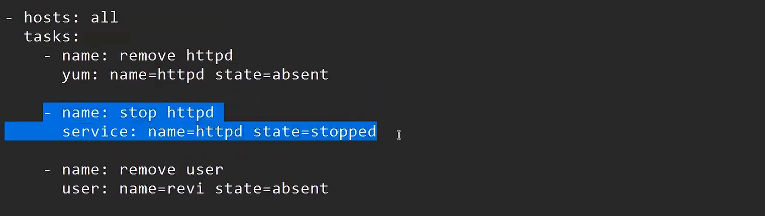

TAGS: use to execute or skip a specific tasks

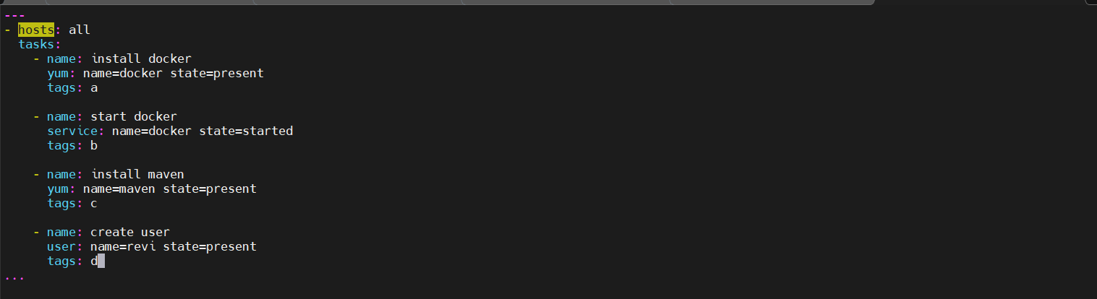

To perform only particular tags or tasks

ansible-playbook playbook.yml --tags a,b (single or multi tags)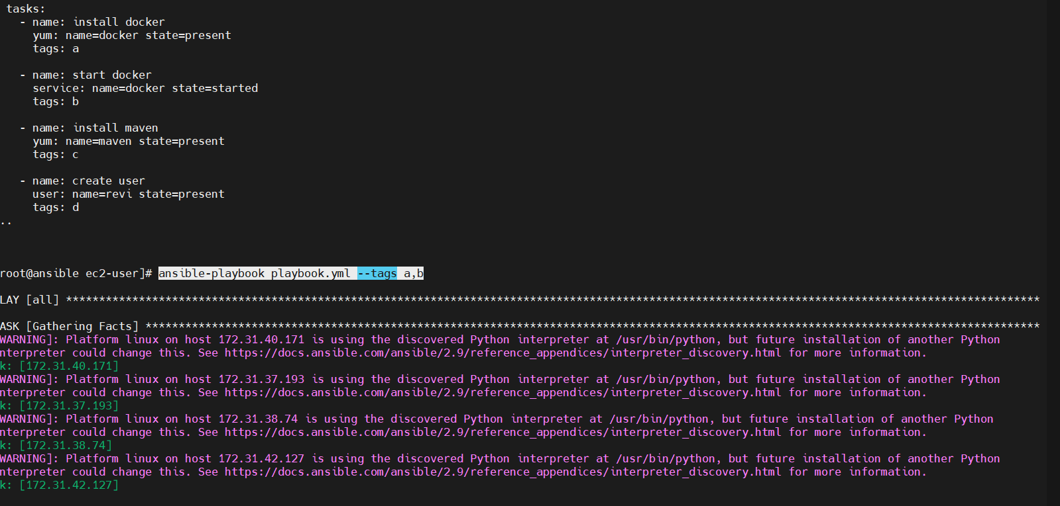

To perform all tasks except one (SKIP TAGS/ multiskip tags)

ansible-playbook playbook.yml --skip-tags "b,c"

**CLASS 23**

**ANSIBLE SHELL VS COMMAND VS RAW**

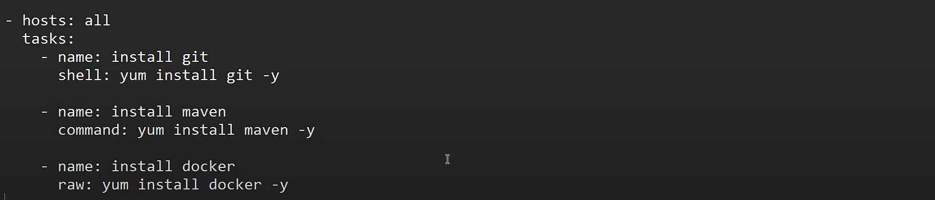

RAW >> COMMAND >> SHELL – command is the best due to some security concerns

To replace all the module with single command - sed -i 's/install/remove/g' aditya.yml

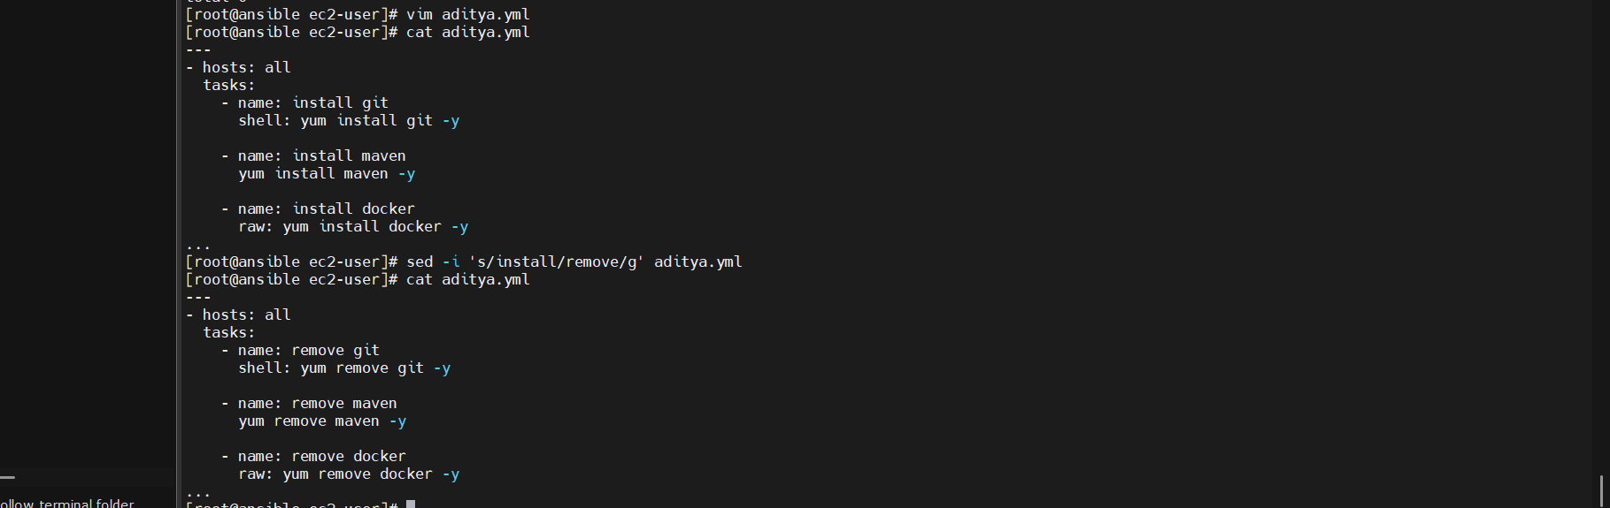

Variables

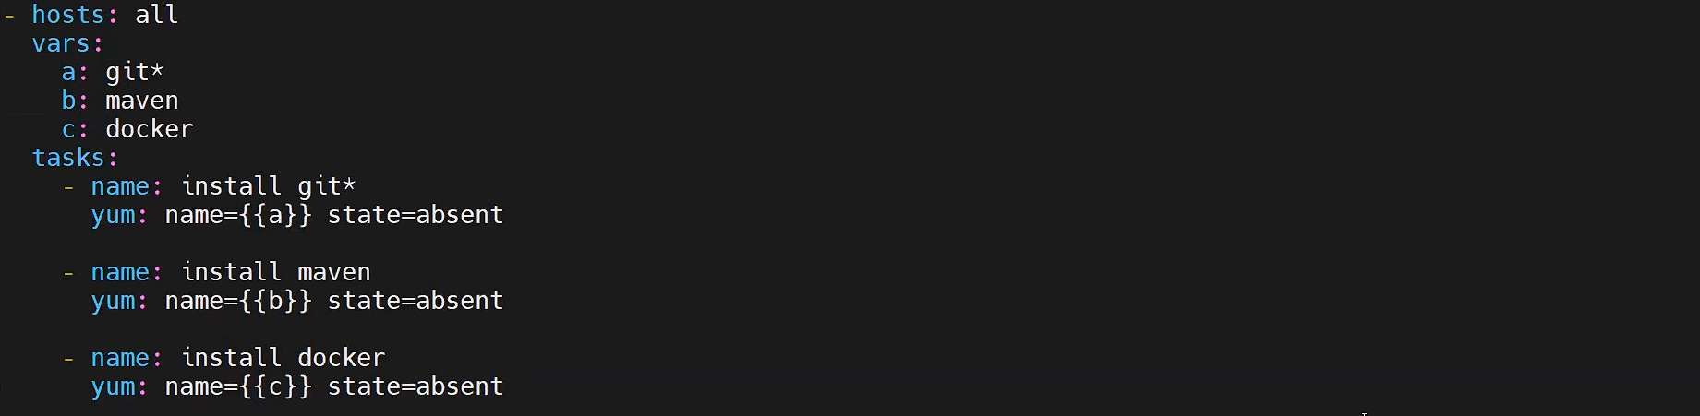

To remove absent to present use command - > :%s/absent/present/g

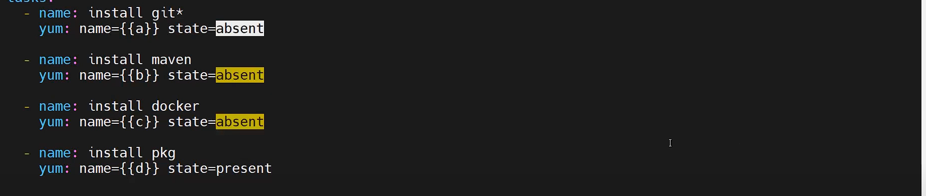



LOOPS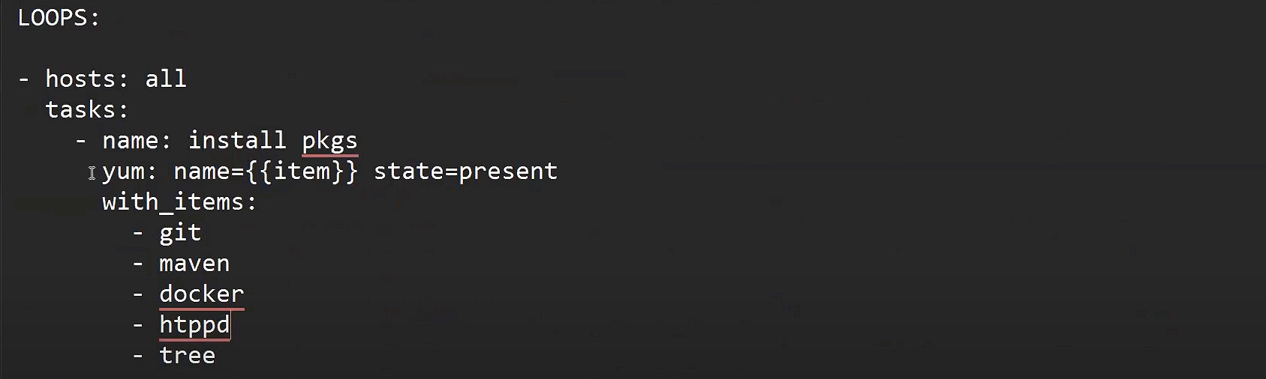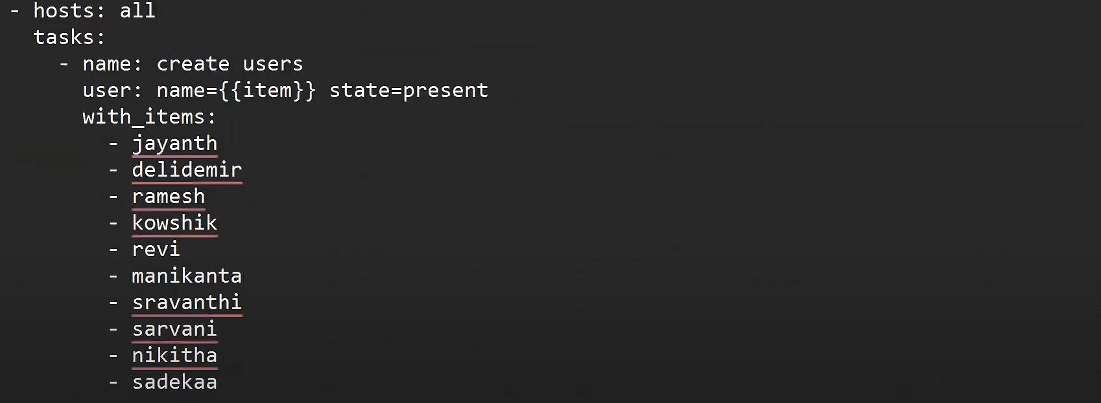

TROUBLESHOOTING:

ansible all -m setup | grep -i cpus

ansible all -m setup | grep -i mem

**CLASS 24**

**ANSIBLE CONDITIONS**

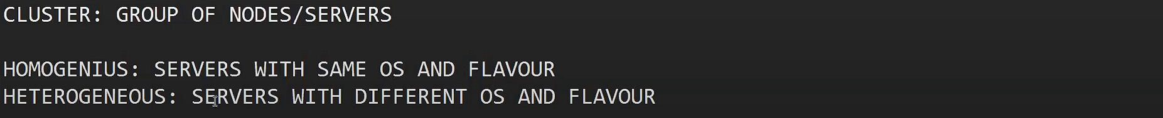

When we have heterogeneous we have to use different package managers for different servers for that we will use conditions   
EX 1 :

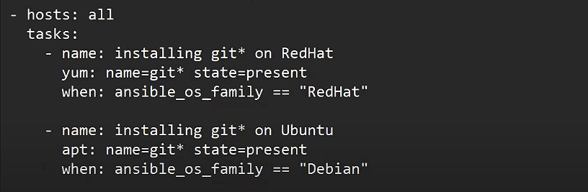

EX2 : 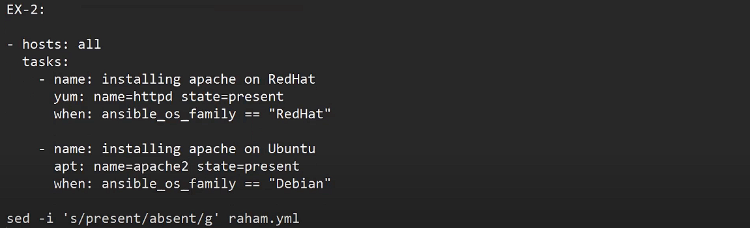

HANDLERS : 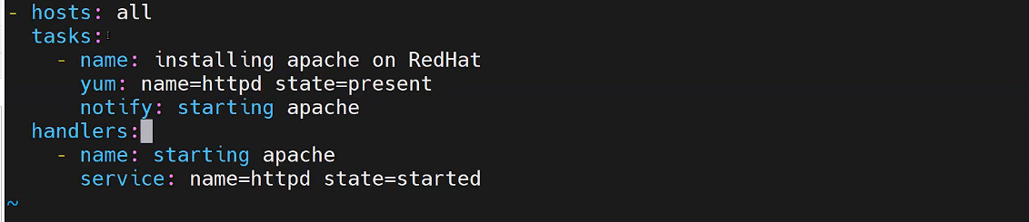

ANSIBLE VAULT : 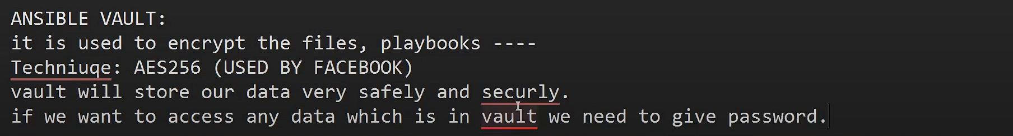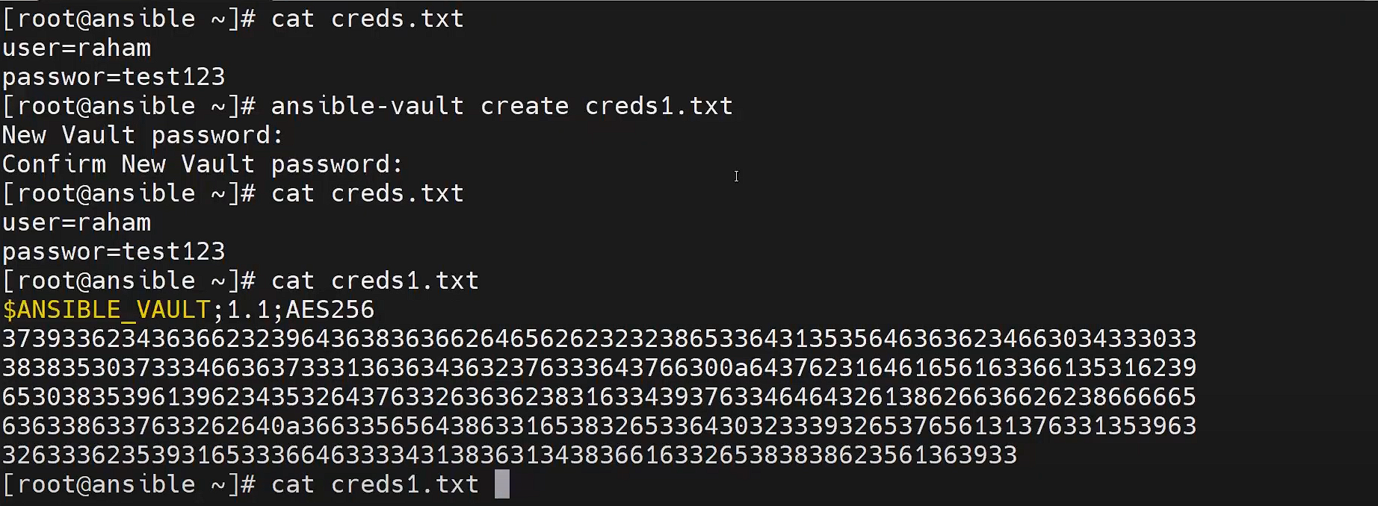changing the password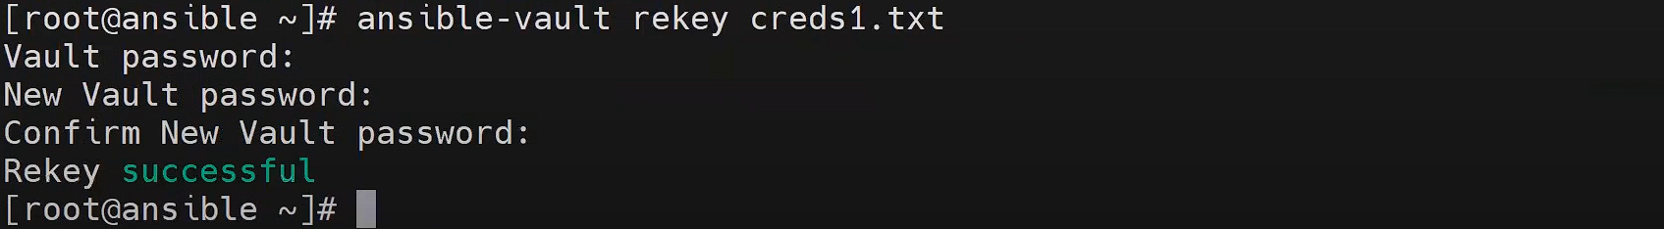  


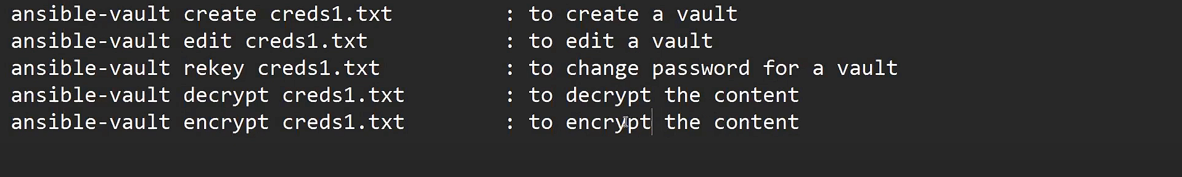

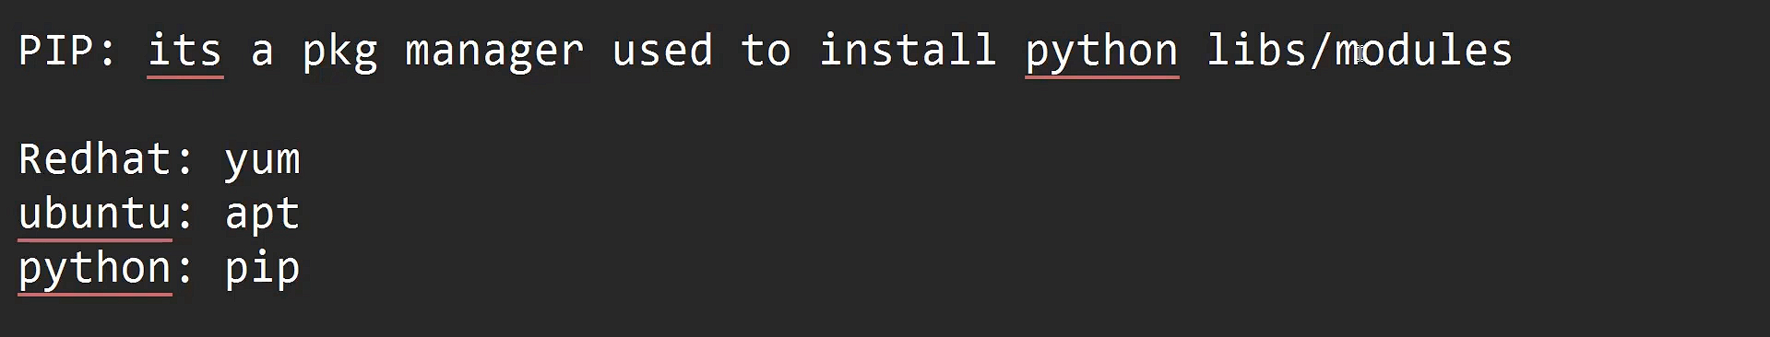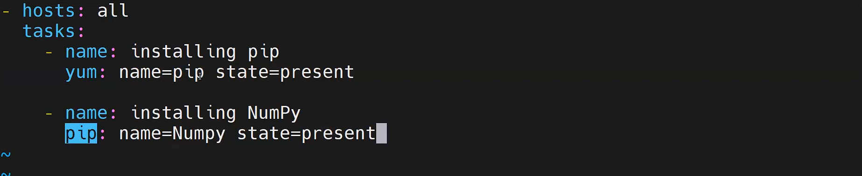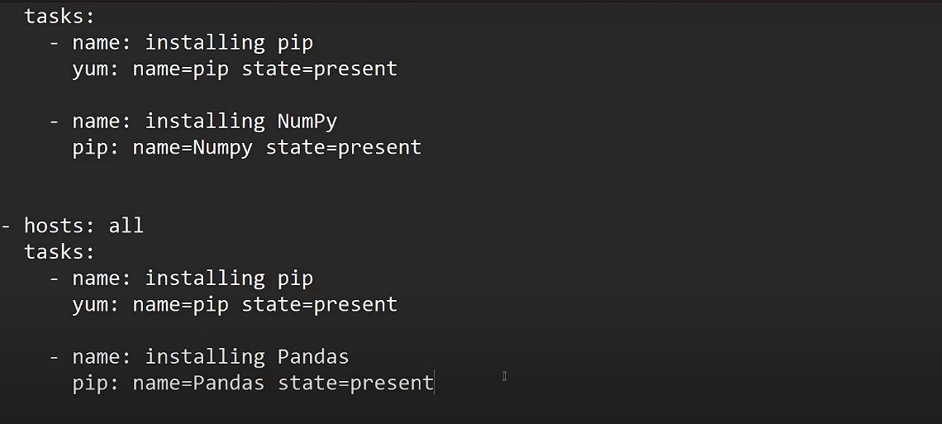

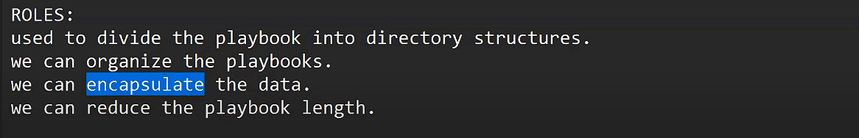

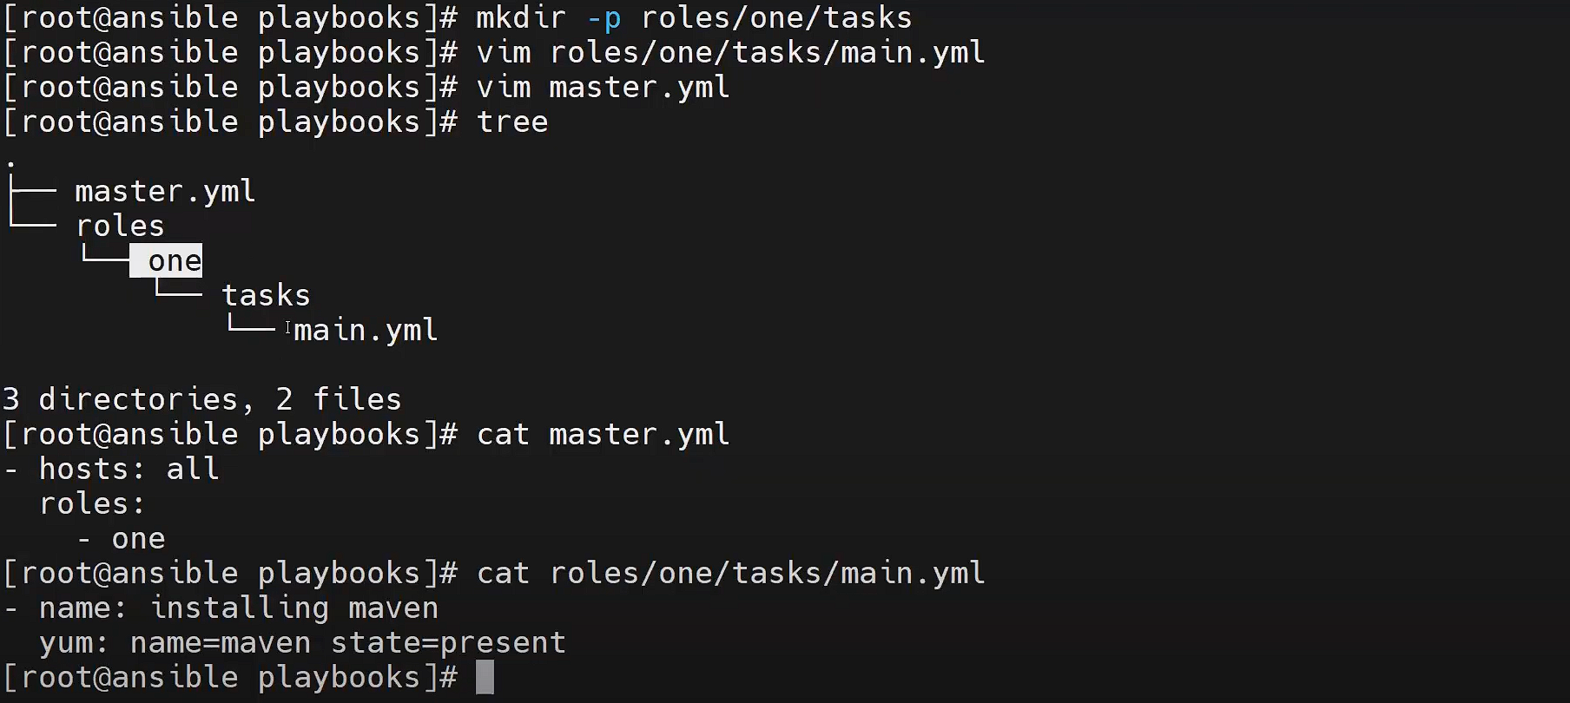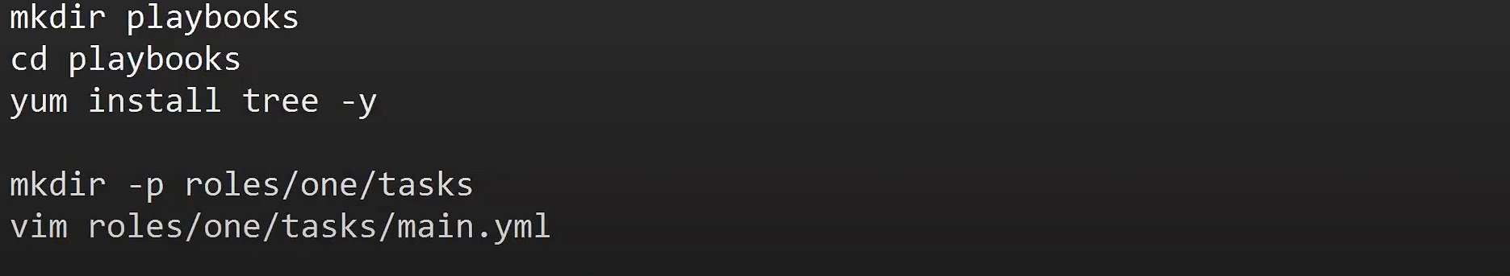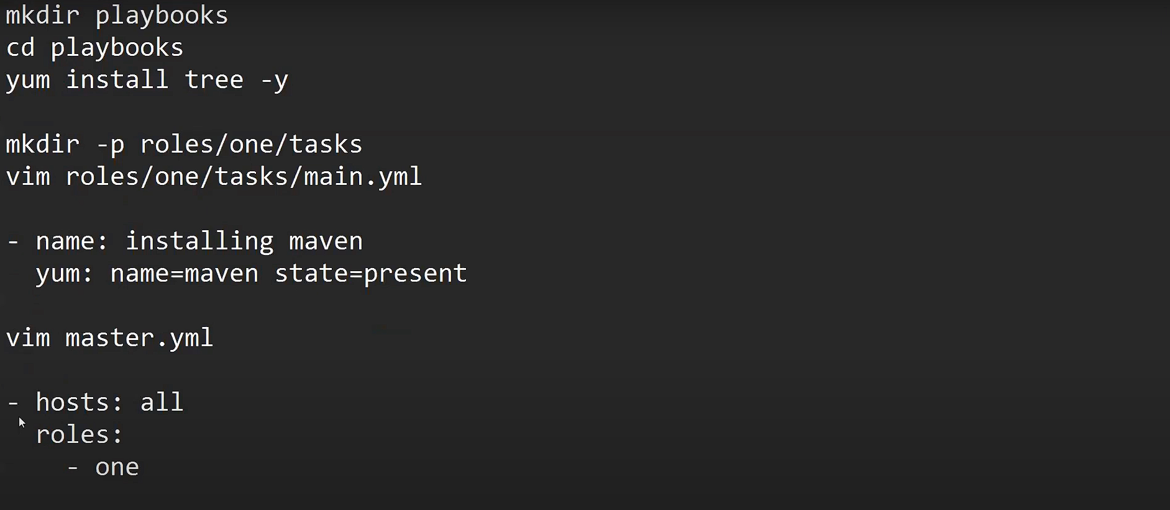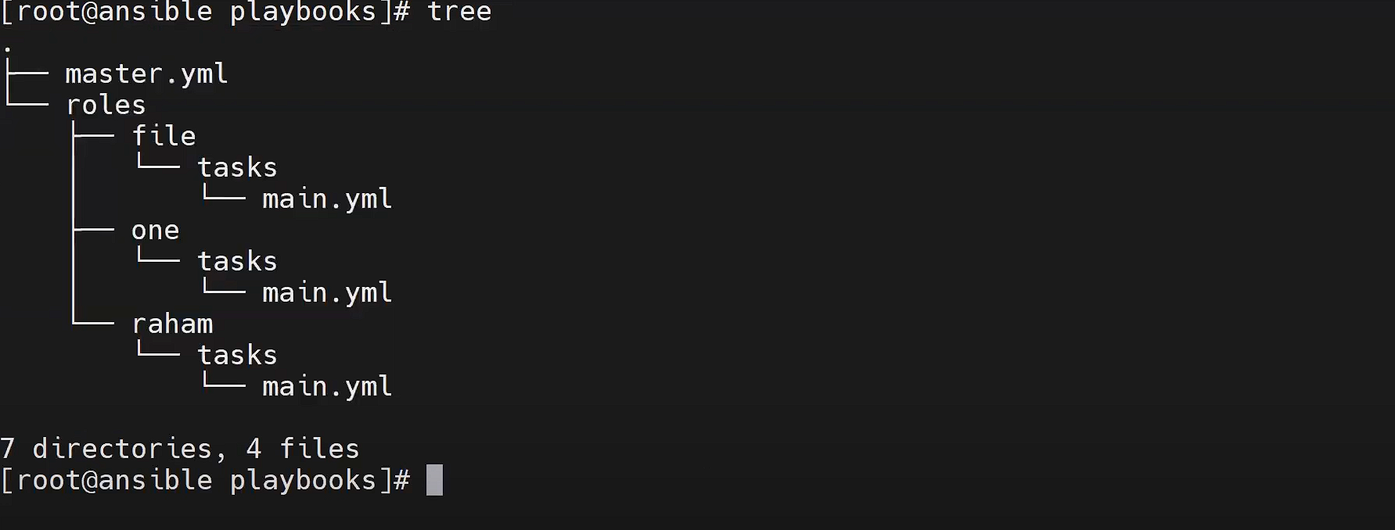

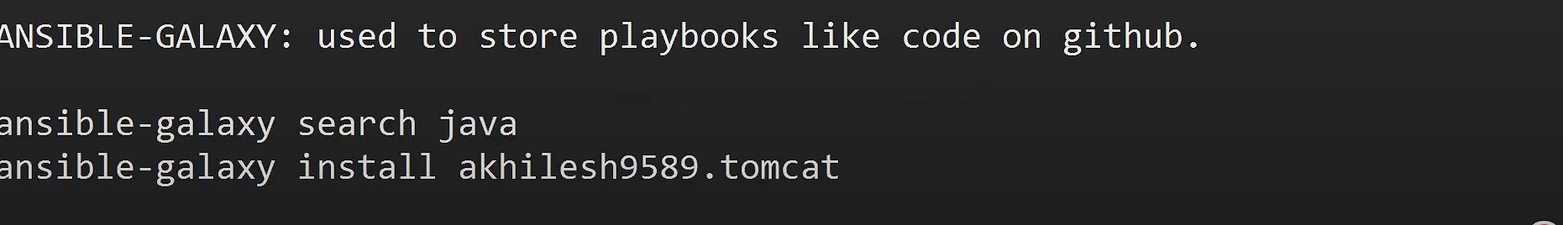

**CLASS 25**

**Ansible Lamp Stack**

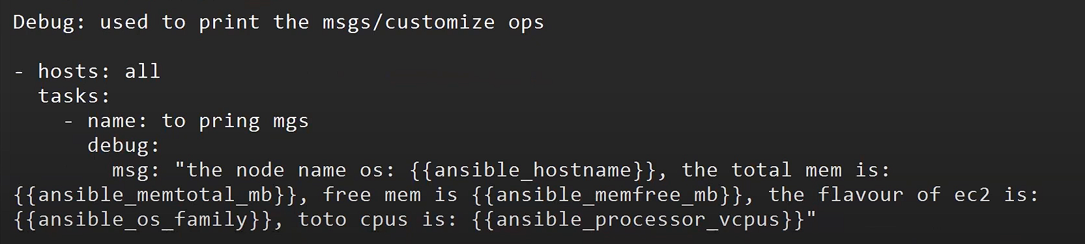

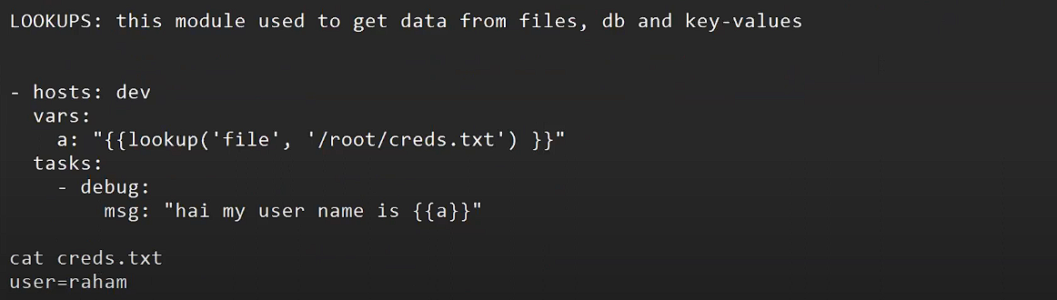

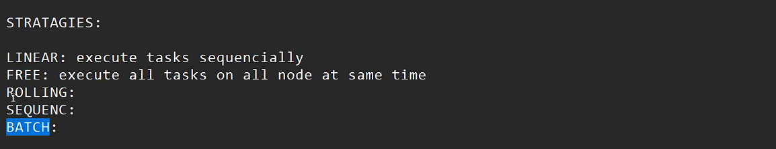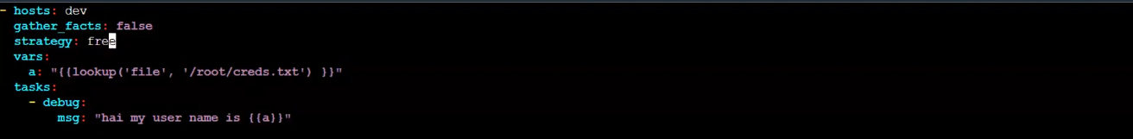if you ue gather_fact = false then output will not wxecute , in real time you will nerver use it , its a blendar mistake

**LAMP : LINUX, APACHE, MYSQL, PHP**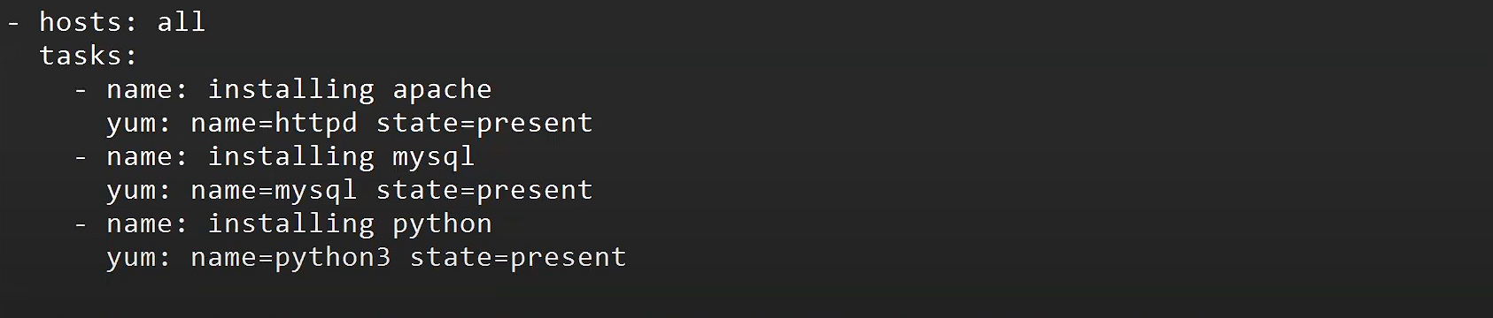

**Now we will deploy Netflix clone**

Step1: get the netflix.yaml code from all-setup repo  
step2: paste in vim netflix.yml  
step3: ansible-playbook netflix.yml  
step4: now you will see that at both server my my frontend is deployed- paste ip on browser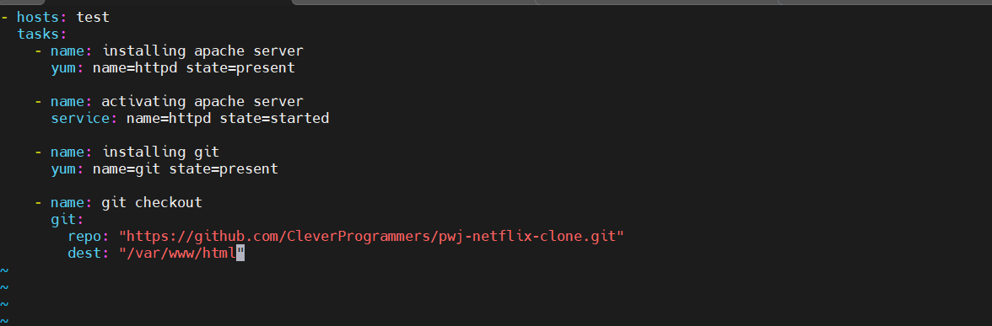you can deploy on dev severs too

-> now if you want to deploy a java file you need to intall tomcat apache  
so make a file vim tomcat.yaml and paste the code from all-setup repo  
->verify the version and update it now make a file again you will find these codes on all-setup repo pate it and run now tomcat will be deployed